Exercise: CI/CD in GitHub Actions
Exercises for the DevOps for Developers module @ SoftUni

CI Workflow – "Student Registry" App

Step 1: Run the App Locally
We have the "Student Registry" Node.js app in the resources. Your task is to create a CI workflow in GitHub Actions to start and test the app on three different Node.js versions:
Let's first start the app locally in Visual Studio Code. To do this, you should open the project, open a new terminal from [Terminal] [New Terminal] and execute the "npm install" and "npm start" commands:
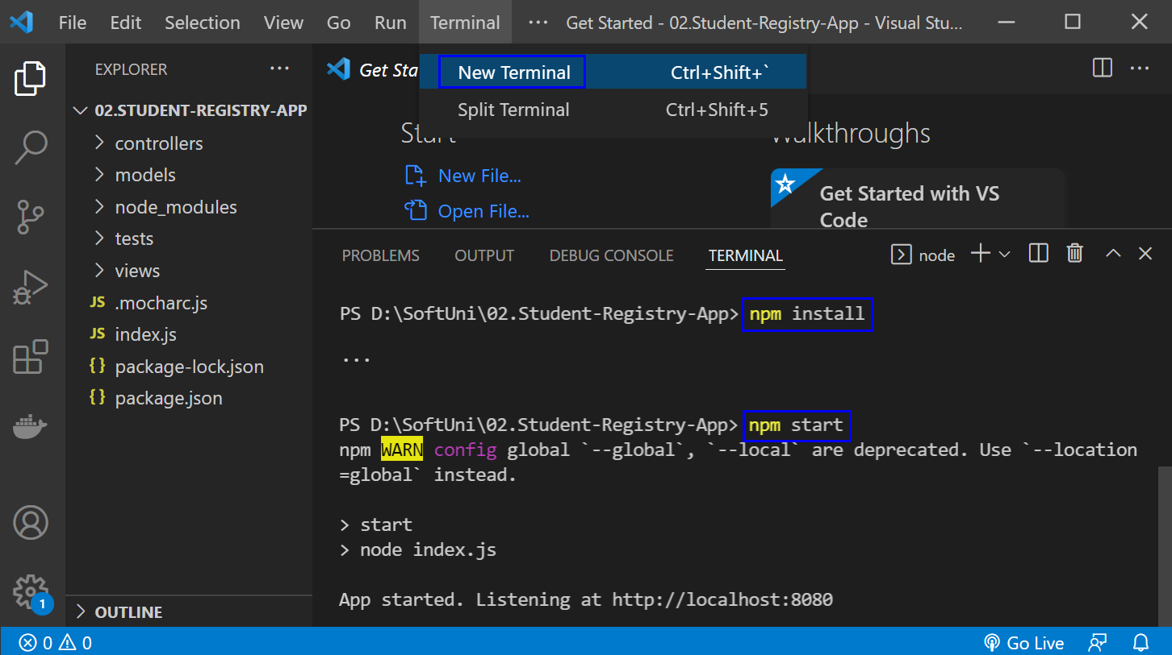
The "npm install" command installs app dependencies from the package.json file and "npm start" starts the app. You can look at the app on http://localhost:8080:
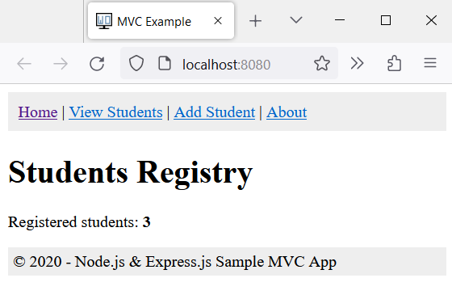
Then, you can return to Visual Studio Code, open a new terminal with [+] and run "npm test" to run the app tests. They should be successful:
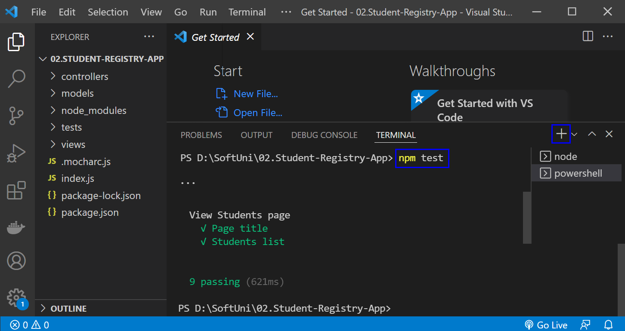
NOTE: if the app was not started, tests would fail because these are integration tests and are executed on the running app.

Step 2: Create a GitHub Repo
Now you should upload the app code to GitHub.
It's a good practice to start using the console and not the interface of GitHub, in case you haven't started doing so yet.
If you don't have Git already installed on your machine, follow the provided installation instructions from the resources.
Try using the following commands in order to initialize a repository in your project directory, add the code to the repo, commit and push:
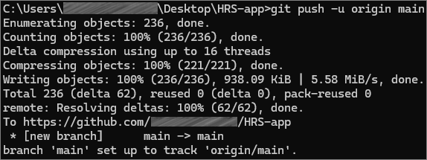
After running the commands, check you GitHub repo – the application code should be visible.

Step 3: Create and Run Workflow
Now you should upload the app code to GitHub and create a GitHub Actions CI workflow to start and test the app. You can use the following template:
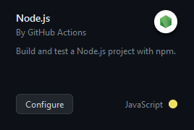
Before you commit the generated YAML workflow file, you should:
- Change the YAML file name to something more meaningful
- Examine the workflow, the job you have and its steps
- Run the job on the last Node.js versions: 18.x
- Change the workflow name
- Modify workflow job steps: you should use the three commands which we used above to start and test the app, not the ones you have in the generated YAML file or your workflow won't be successful
- Add names for each step in your workflow job
Finally, run the workflow job and make sure that it is successful:
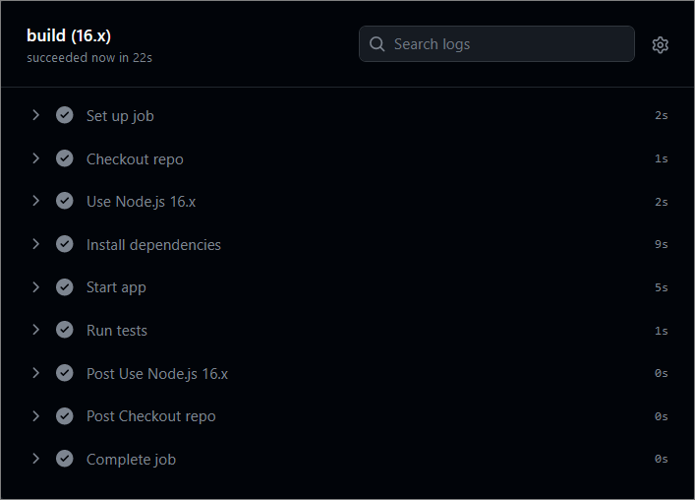

CD Workflow – "Student Registry" App
Now, let's create a CD workflow for the "Student Registry" Node.js app to deploy it to Render.com.
We will continue working on the file that we created for the CI workflow.
To do this, you should fulfill the following steps:
- Create a free Render.com account
- Generate an API Token:
  - Navigate to the "API Keys" section in your Render.com Account settings;
  - Generate an API token by clicking on "Create API Key";
  - Give it a meaningful name (e.g., "GitHub Actions Token");
  - Click on "Create Token" to generate it.
- Add a new Web Service:
  - Connect your GitHub account to the service;
  - Connect your GitHub repository holding the application;
  - Give your service a unique and meaningful name;
- Add Render Service ID as a GitHub Secret:
  - Go to the Settings menu of your web service in Render.com and find the Deploy Hook;
  - Copy the value that matches the pattern from the red square:
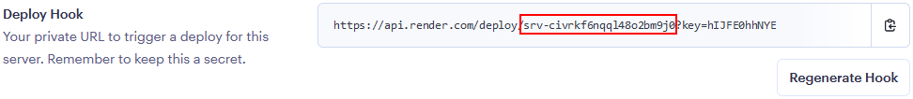
  - Go to your GitHub repository, click on "Settings," then select "Secrets and variables" from the left sidebar;
  - Click on "Actions" and then click on "New repository secret" and add a new secret with the following details:
    - Name: SERVICE_ID
    - Value: The service id that you copied from Render.com
  - Click "Add secret" to save it.
- Add Render.com API Token as a GitHub Secret:
  - Go to your GitHub repository, click on "Settings," then select "Secrets and variables" from the left sidebar;
  - Click on "Actions" and then click on "New repository secret" and add a new secret with the following details:
    - Name: RENDER_TOKEN
    - Value: The API token you generated on Render.com
  - Click "Add secret" to save it.
- Create and define the CD workflow:
  - Set the job to be dependent of the test job from the CI workflow
  - In the YAML file that we used for the CI workflow, use the custom GitHub action johnbeynon/render-deploy-action@v0.0.8 to deploy the application to Render;
  - Use the Render service ID and API key, which are stored as secrets in the repository.
GitHub Actions will execute the CD workflow, which involves installing Node.js, installing dependencies, and deploying the app to Render.com. The workflow will log in to Render.com using the API token you provided as a secret and then deploy your app.
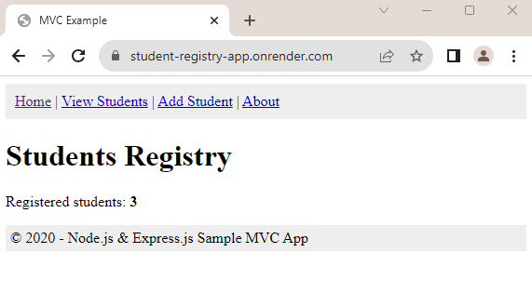

* CI/CD Workflow – "Library Catalog" App
We have the "Library Catalog" app in the resources. Your task is to create a CI/CD workflow in GitHub Actions to start, test and deploy the app to Render.com following the steps from the previous tasks.


"HouseRentingSystem" App – ASP.NET Core MVC app

Step 1: Run the App Locally
We have the "HouseRentingSystem" ASP.NET Core MVC app in the resources which has some unit and integration tests already. Your task is to create a CI workflow with GitHub Actions to start and test the app.
It's a good practice to first start the app locally in Visual Studio, in order to be sure everything works properly and as expected.
Open Visual Studio and from there navigate to the Tools menu. Select NuGet Package Manager and select Package Manager Console:
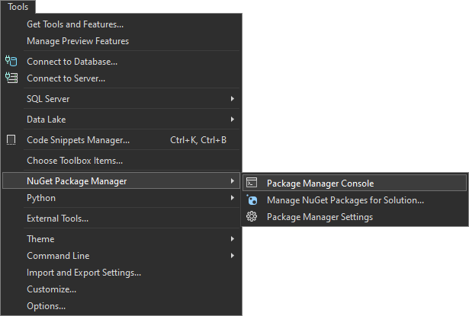
Let's first build the application by using the dotnet build command:
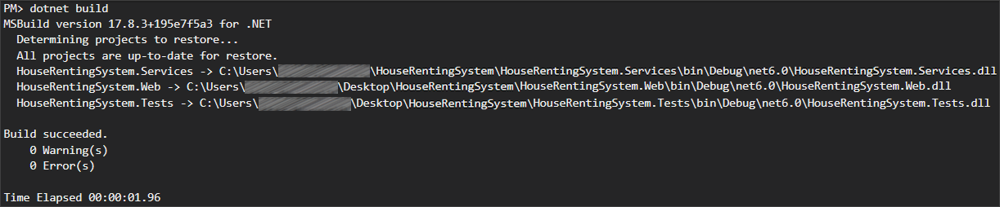
After you have ensured that the build was successful, you can run the tests, too, by using the dotnet test command:
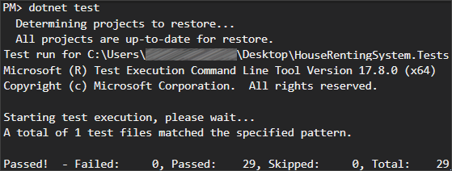
NOTE: Visual Studio has built-in test runners that allow you to run your tests directly from the IDE. This is the simplest way to execute tests if you're already working within Visual Studio. However, it's better to get used using the console.
After we have ensured that the tests run successfully, we can proceed with the next step.

Step 2: Create a GitHub Repo
Now you should upload the app code to GitHub. Try using the CLI and the commands from the previous task to add the code to the repo and commit it.

Step 3: Create and Run Workflow
Now you should create a GitHub Actions CI workflow to start and test the app.
You can use the following template:
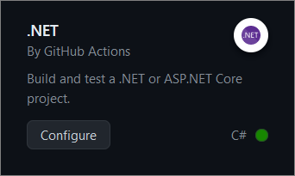
Before you commit the generated YAML workflow file, you should:
- Change the YAML file name to something more meaningful
- Examine the workflow, the job you have and its steps
- Run the job on .NET version 6.0
- Change the workflow name
- Modify workflow job steps: you should have jobs for
  - Setting up .NET Core
  - Restoring dependencies
  - Building the app
  - Running the tests
- Add names for each step in your workflow job
Finally, run the workflow job and make sure that it is successful:
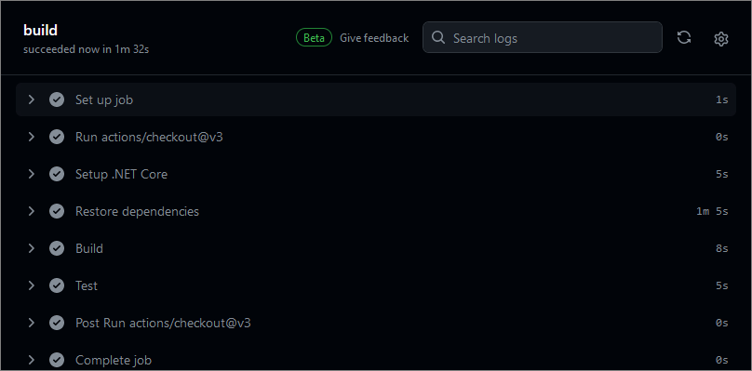

Selenium IDE

Step 1: Run the App Locally
We have the "SeleniumIde" solution in the resources which has one test projects already. Your task is to create a CI workflow with GitHub Actions to run the tests automatically.
It's a good practice to build the solution locally in Visual Studio, in order to be sure everything works properly and as expected.
Open Visual Studio and from there navigate to the Tools menu. Select NuGet Package Manager and select Package Manager Console:

Let's first build the application by using the following command:
dotnet build
After you have ensured that the build was successful, you can run the tests, too, by using the command below or just by clicking on the [Run All Tests in View] button in the Text Explorer.
dotnet test
After we have ensured that the tests run successfully, we can proceed with the next step.

Step 2: Create a GitHub Repo
Now you should upload the solution to GitHub.
It's a good practice to start using the console and not the interface of GitHub, in case you haven't started doing so yet.
If you don't have Git already installed on your machine, follow the provided installation instructions from the resources.
Try using the following commands in order to initialize a repository in your project directory, add the code to the repo, commit and push:
git init
git add .
git commit -m "Initial commit"
git remote add origin https://github.com/{name-of-your-repository}
git push -u origin main
After running the commands, check you GitHub repo – the application code should be visible.

Step 3: Add Changes to Test Files
Before creating the workflow file, we have to make some adjustments in the .cs files. This is needed due to the fact that the default GitHub runner does not have Chrome installed. We will take care of this in the workflow, but we also need the prepare the tests to run Chrome in a headless mode within the CI environment.
In order to do that, go to the SetUp() method of the project and modify it so it looks like below:
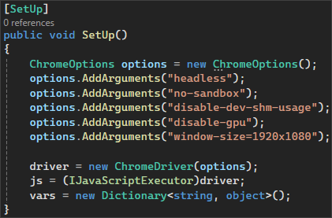
Don't forget to commit and push the changes from the file.

Step 4: Create and Run Workflow
Now you should create a GitHub Actions CI workflow to start and test the app.
In the root directory of the repository, create a new folder .github and in it create another one, called workflows. Then, inside this new folder, create a YAML file, which will hold the workflow definition.
Now, let's define our workflow file.
We have to give it a meaningful name and specify the event which will trigger the workflow. In our case, this will be the push and pull request events on the main branch:
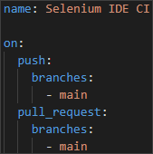
Then, we have to specify the job and the environment:
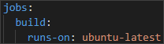
After that, we start defining the steps. You have to create several steps for the job:
- Checkout code
  - Give the step a meaningful name
  - Checkout the repository code
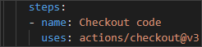
- Set up .NET Core
  - Give the step a meaningful name
  - Use the appropriate action to set up the .NET Core SDK
    - Specify the .NET Core version
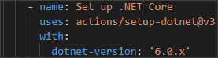
- Install Chrome
  - Give the step a meaningful name
  - Executes commands to update the package list and install Google Chrome
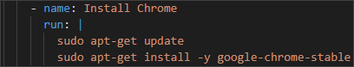
- Install dependencies
  - Give the step a meaningful name
  - Run the appropriate command to restore the dependencies specified in the solution file
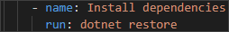
- Build the solution
  - Give the step a meaningful name
  - Run the appropriate command to build the solution without restoring the dependencies again
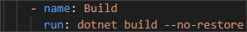
- Run the test project
  - Give the step a meaningful name
  - Sets the environment variable CHROMEWEBDRIVER to the path of the Chrome executable
  - Run the tests in the project with normal verbosity
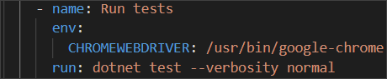
Now, commit the changes to the main branch of the repository.
Finally, the workflow job should run after the commit. Make sure that it is successful:
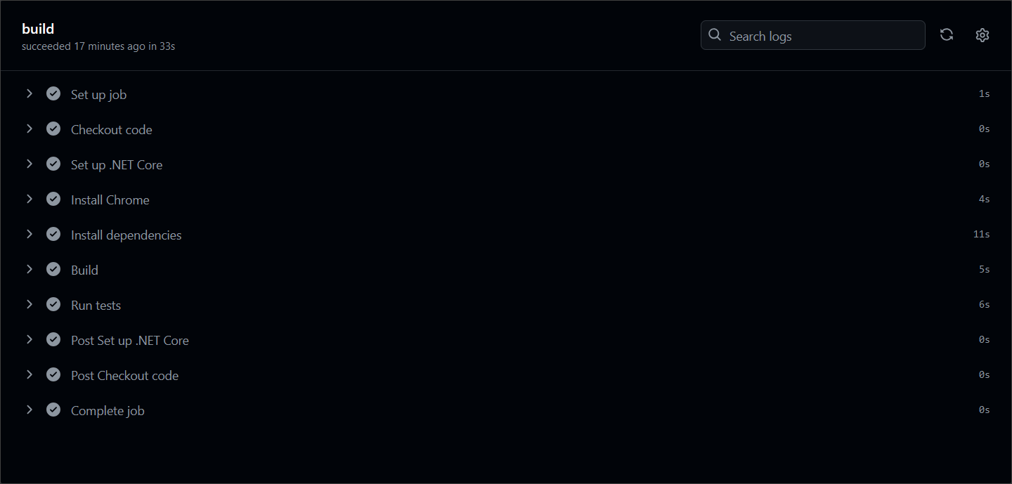

Selenium Web Driver
Our second task will be to create a CI for using Selenium to automate several test projects, combined in one solution.

Step 1: Run the App Locally
We have the "SeleniumBasicExercise" solution in the resources which has four test projects already. Your task is to create a CI workflow with GitHub Actions to run the tests automatically.
It's a good practice to build the solution locally in Visual Studio, in order to be sure everything works properly and as expected.
Open Visual Studio and from there navigate to the Tools menu. Select NuGet Package Manager and select Package Manager Console:

Let's first build the application by using the dotnet build command:
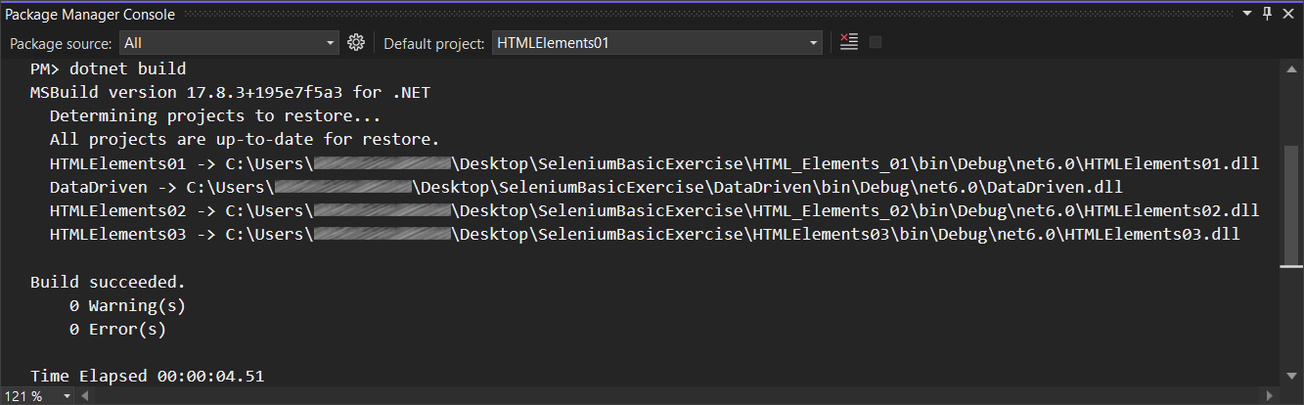
After you have ensured that the build was successful, you can run the tests, too, by using the dotnet test command or just by clicking on the [Run All Tests in View] button in the Text Explorer.
After we have ensured that the tests run successfully, we can proceed with the next step.

Step 2: Create a GitHub Repo
Now you should upload the solution to GitHub.
It's a good practice to start using the console and not the interface of GitHub, in case you haven't started doing so yet.
If you don't have Git already installed on your machine, follow the provided installation instructions from the resources.
Try using the following commands in order to initialize a repository in your project directory, add the code to the repo, commit and push:
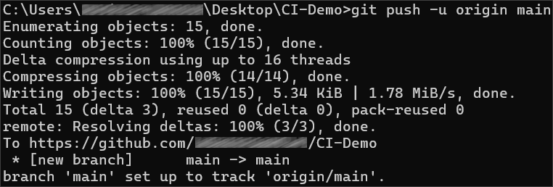
After running the commands, check you GitHub repo – the application code should be visible.

Step 3: Add Changes to Test Files
Before creating the workflow file, we have to make some adjustments in the .cs files. This is needed due to the fact that the default GitHub runner does not have Chrome installed. We will take care of this in the workflow, but we also need the prepare the tests to run Chrome in a headless mode within the CI environment.
In order to do that, go to the SetUp() method of each project and add the following code:
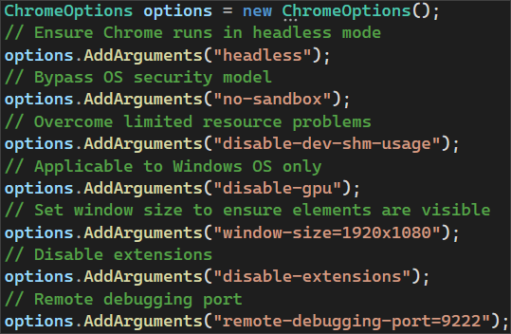
Then, we need to pass the ChromeOptions to the ChromeDriver constructor:
Don't forget to commit and push the changes to each one of the files.

Step 4: Create and Run Workflow
Now you should create a GitHub Actions CI workflow to start and test the app.
In the root directory of the repository, create a new folder .github and in it create another one, called workflows. Then, inside this new folder, create a YAML file, which will hold the workflow definition.
Now, let's define our workflow file.
We have to give it a meaningful name and specify the event which will trigger the workflow. In our case, this will be the push and pull request events on the main branch:
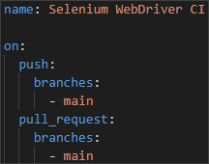
Then, we have to specify the job and the environment:

After that, we start defining the steps. You have to create several steps for the job:
- Checkout code
  - Give the step a meaningful name
  - Checkout the repository code

- Set up .NET Core
  - Give the step a meaningful name
  - Use the appropriate action to set up the .NET Core SDK
    - Specify the .NET Core version

- Install Chrome
  - Give the step a meaningful name
  - Executes commands to update the package list and install Google Chrome

- Install dependencies
  - Give the step a meaningful name
  - Run the appropriate command to restore the dependencies specified in the solution file
- Build the solution
  - Give the step a meaningful name
  - Run the appropriate command to build the solution without restoring the dependencies again
- Run each test project separately
  - Give each step appropriate and meaningful name, describing which test project is being executed
  - Sets the environment variable CHROMEWEBDRIVER to the path of the Chrome executable
  - Run the tests in each project with normal verbosity
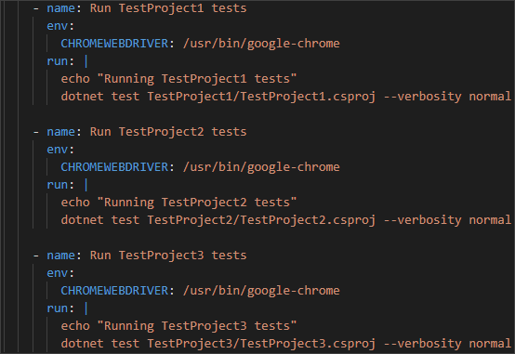
Now, commit the changes to the main branch of the repository.
Finally, the workflow job should run after the commit. Make sure that it is successful:
